

School of Computer Science Engineering & Information Systems (SCORE)

WINTER SEMESTER 2025-2026

Name: M. Divyasri
Registration Number: 23MIS0174
Course Title: Agile Development Process and Devops Lab
Course Code: ISWE406P
Faculty: Dr. Sweta Bhattacharya
Slot: L3+L4

LAB ASSIGNMENT – 3

1. Create a Maven Project in Git
- Create a new Git repository
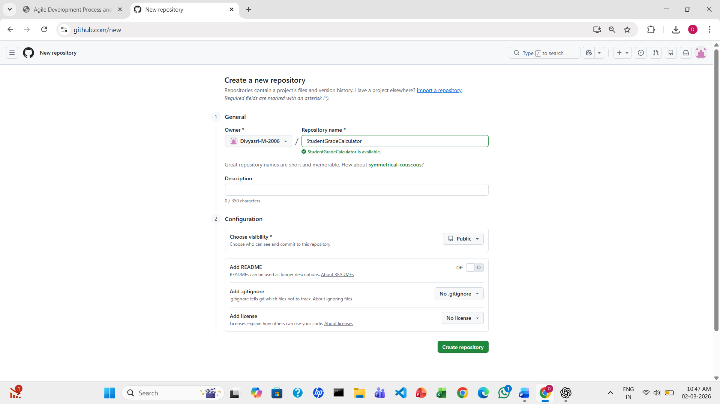
- Clone the Repository Locally
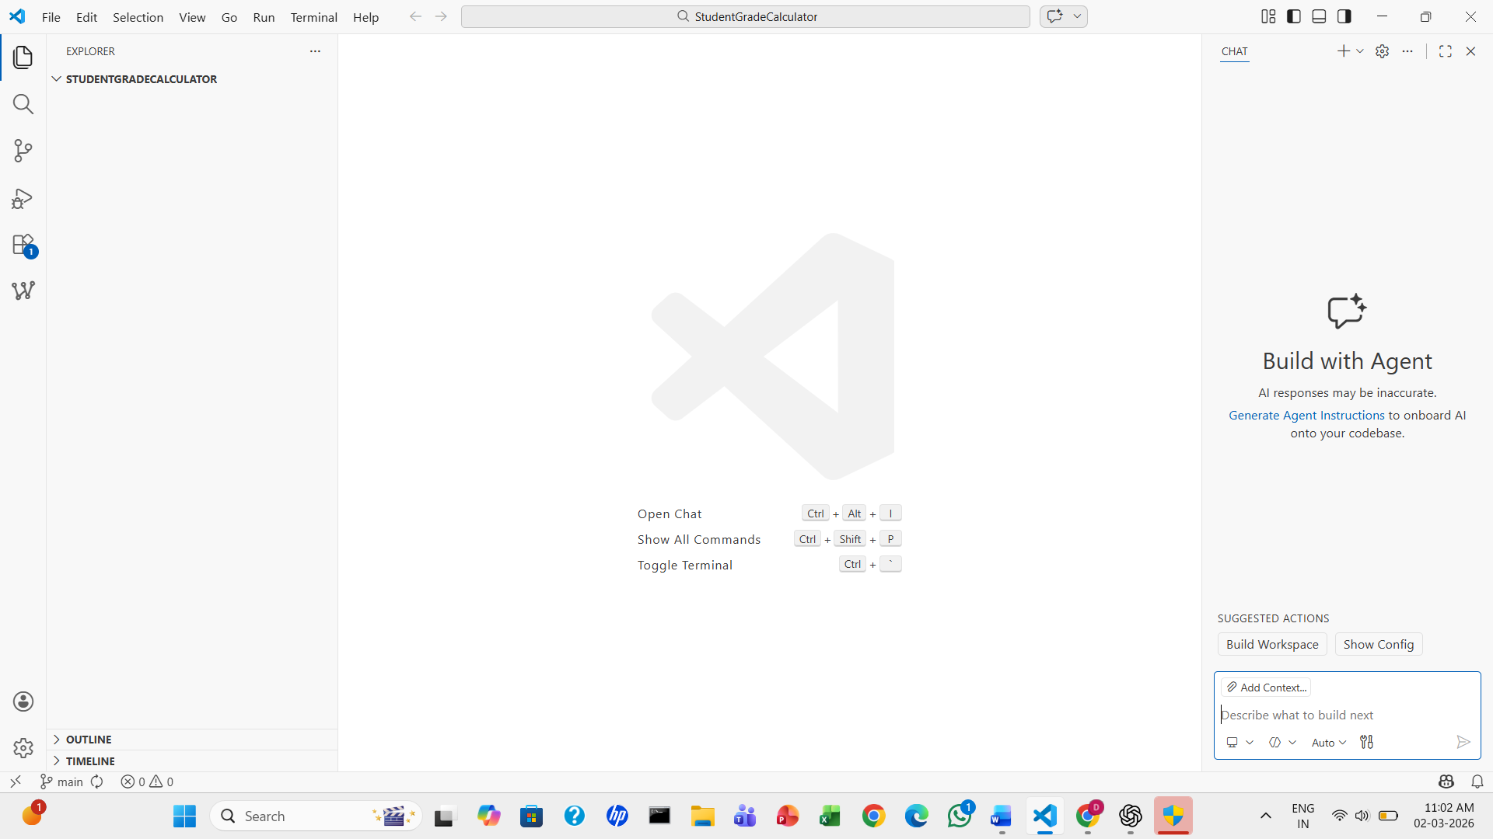

- Create a simple Maven project structure manually, including the following files and folders:
pom.xml
src/main/java/com/example/App.java
src/test/java/com/example/AppTest.java
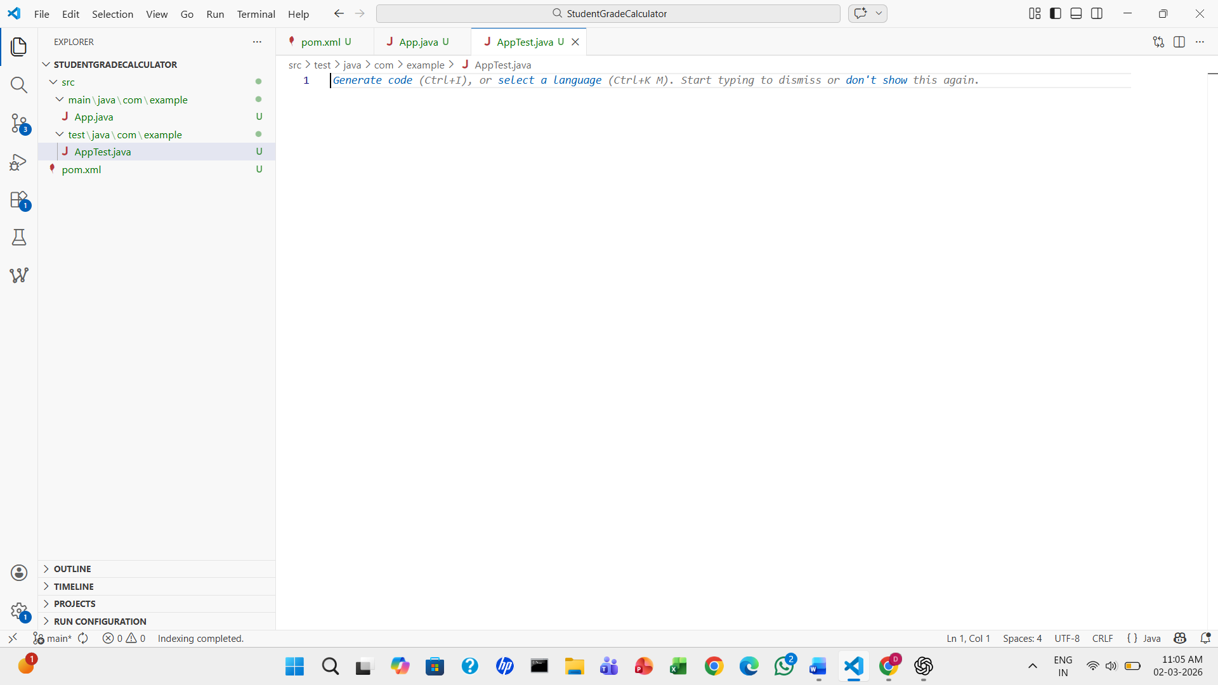
2. Implement the Java Program
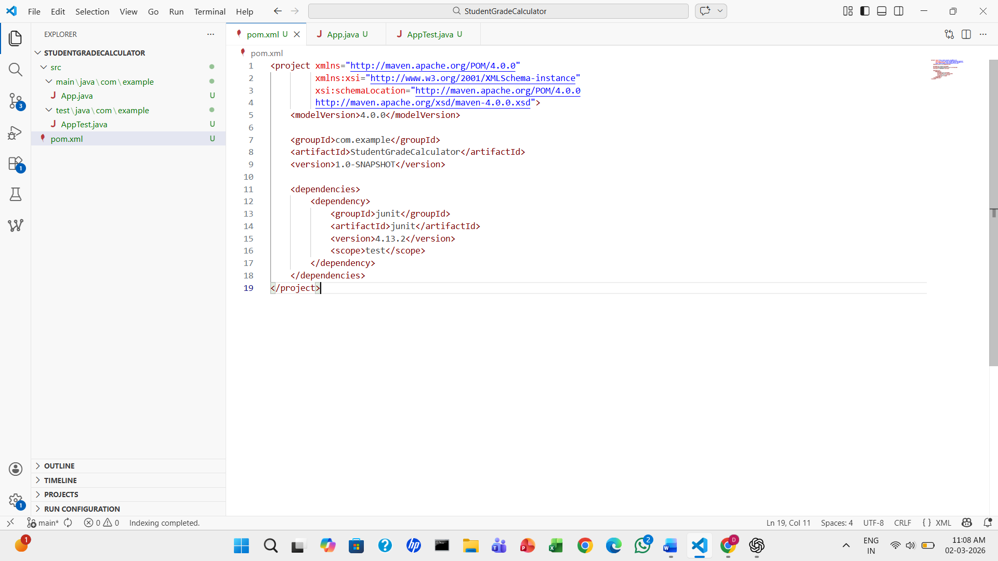

- Write a simple Java program in App.java under your newly created Git repository for Student Grade Calculator:
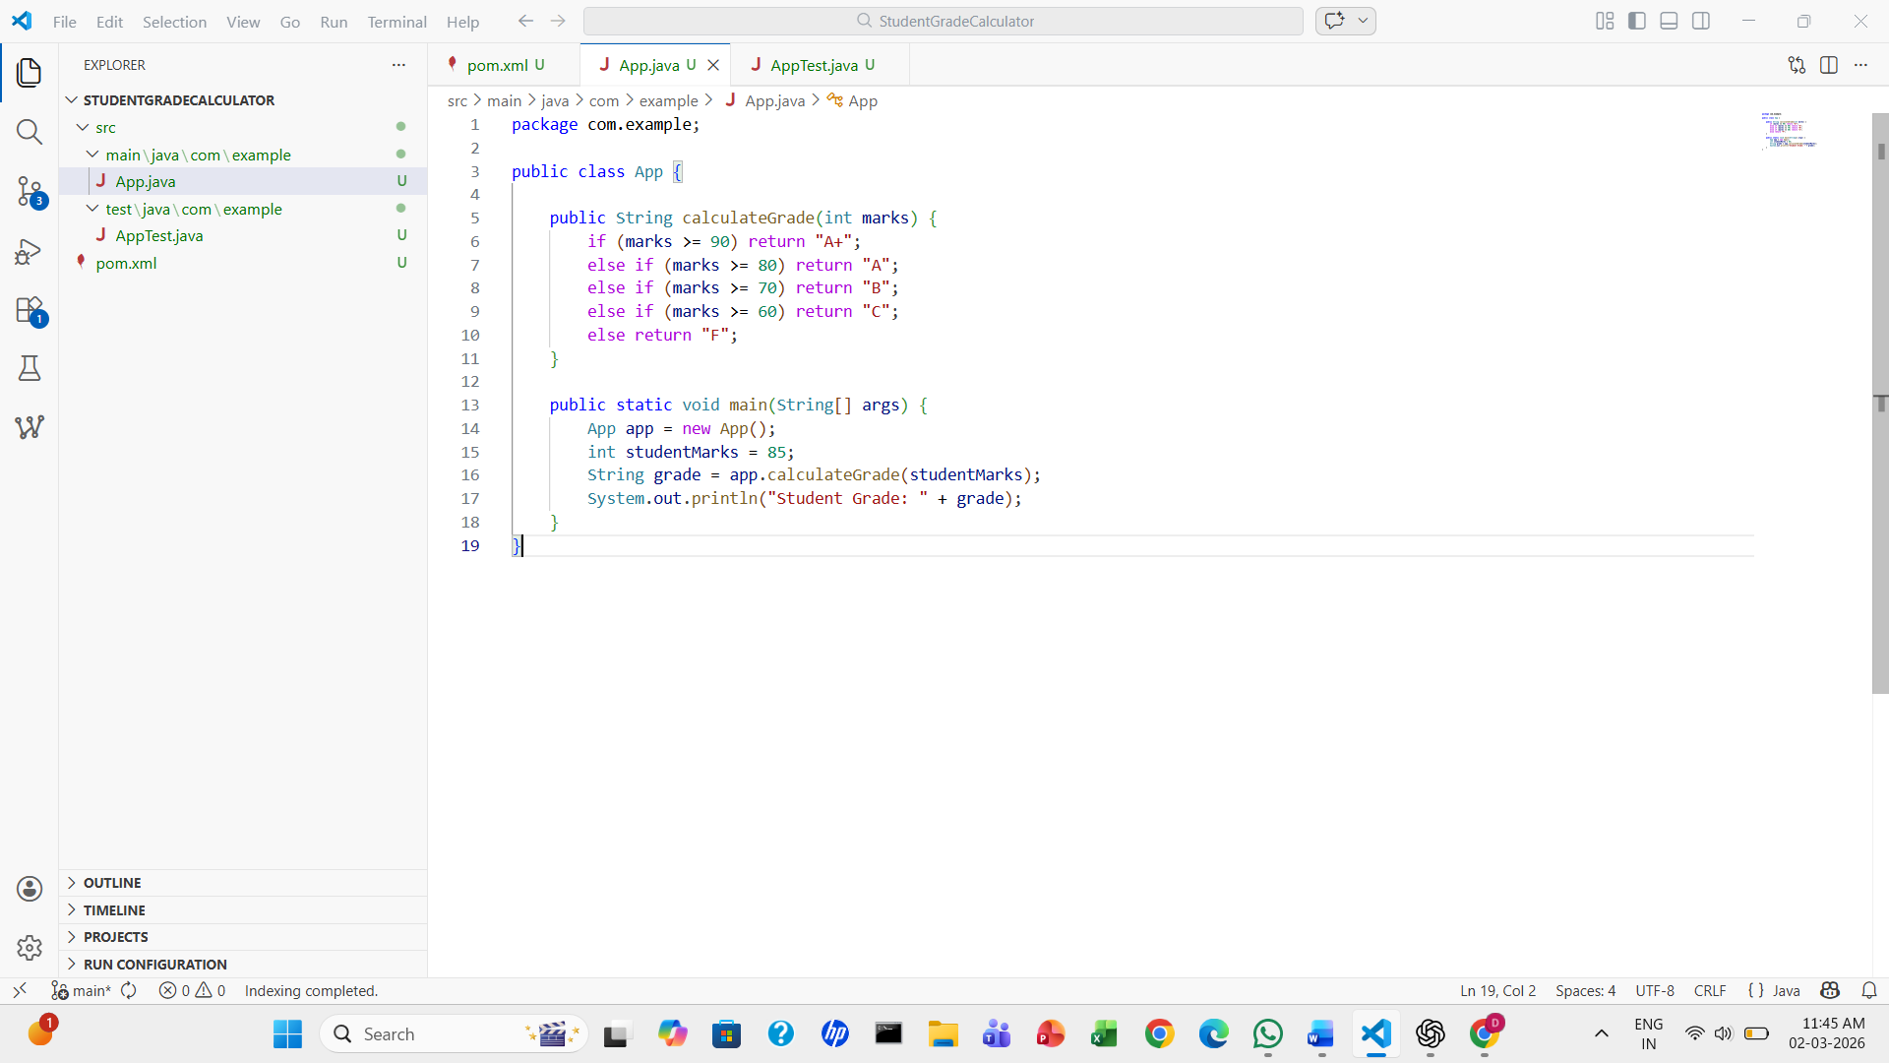
- Write a corresponding unit test in AppTest.java.
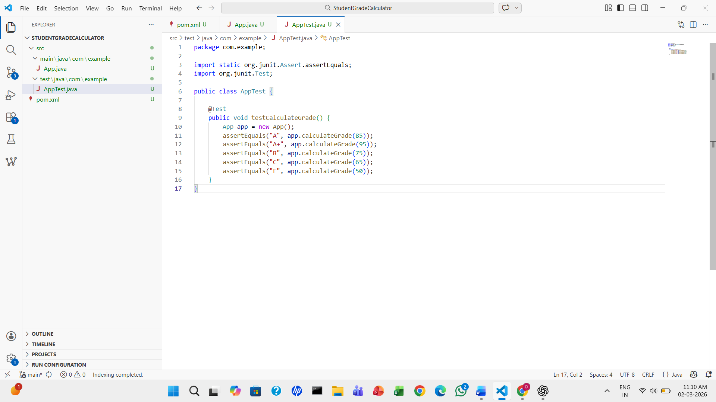

3. Push and Clone the Repository
- Clone the repository using Visual Studio Code.
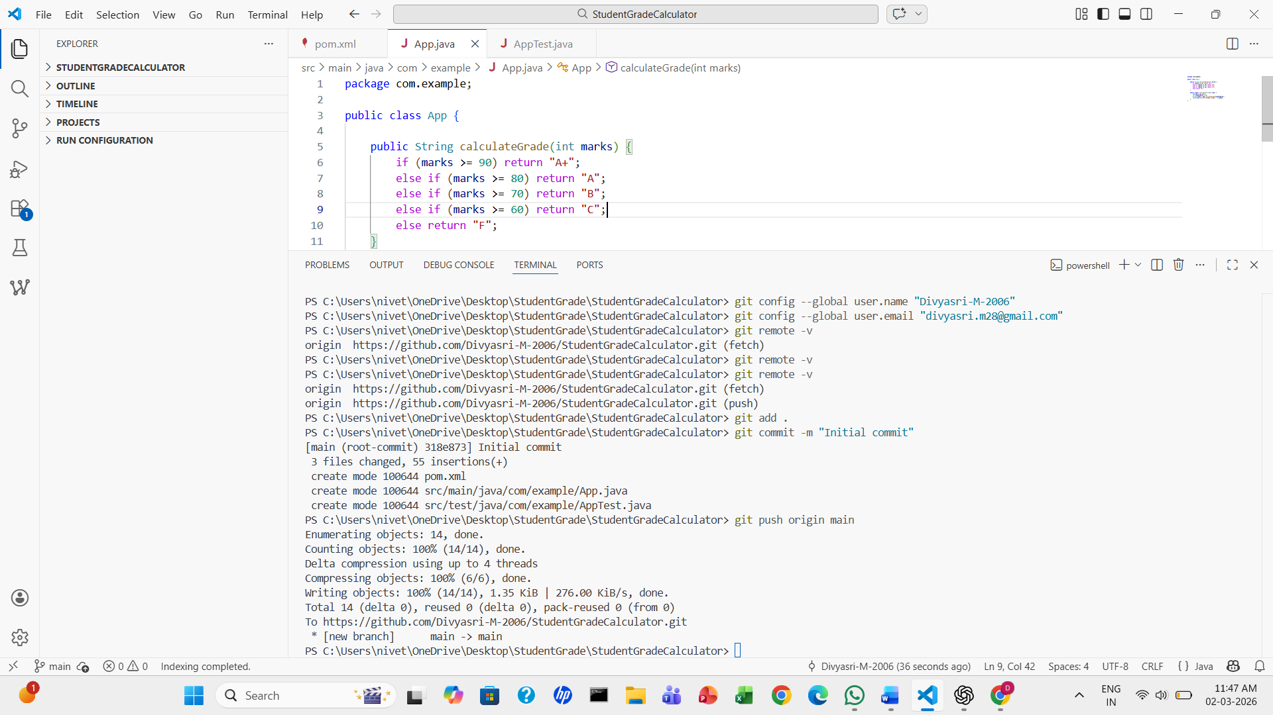
- Verify the project structure.
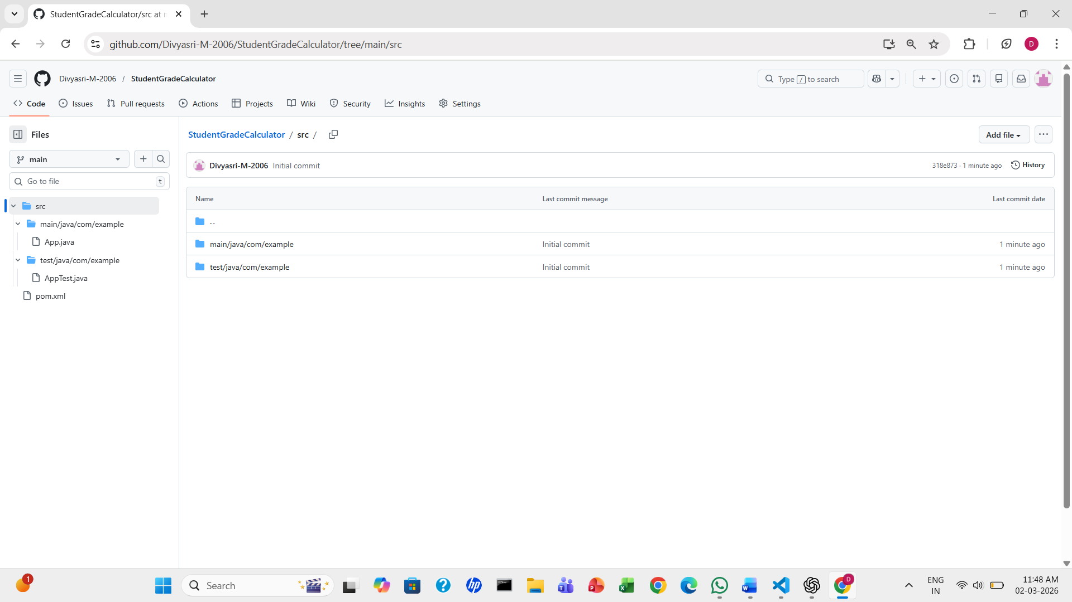

4. Build the Maven Project
- Use Maven commands in Visual Studio Code terminal to:
Compile the project
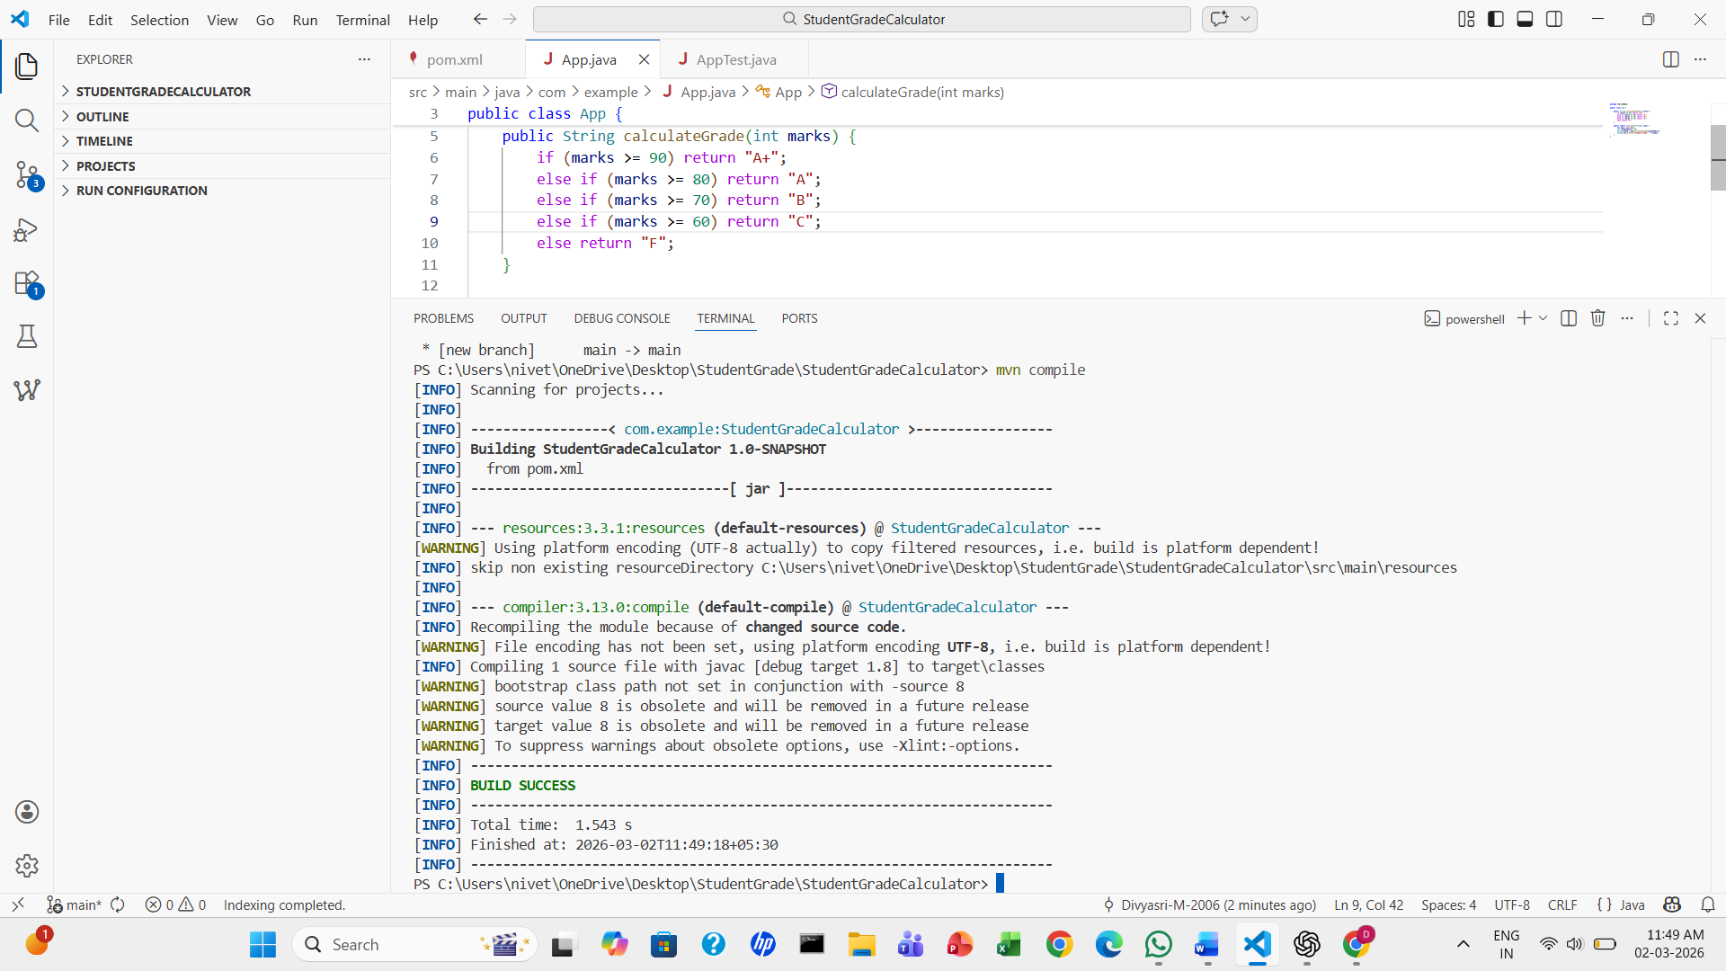
Run tests
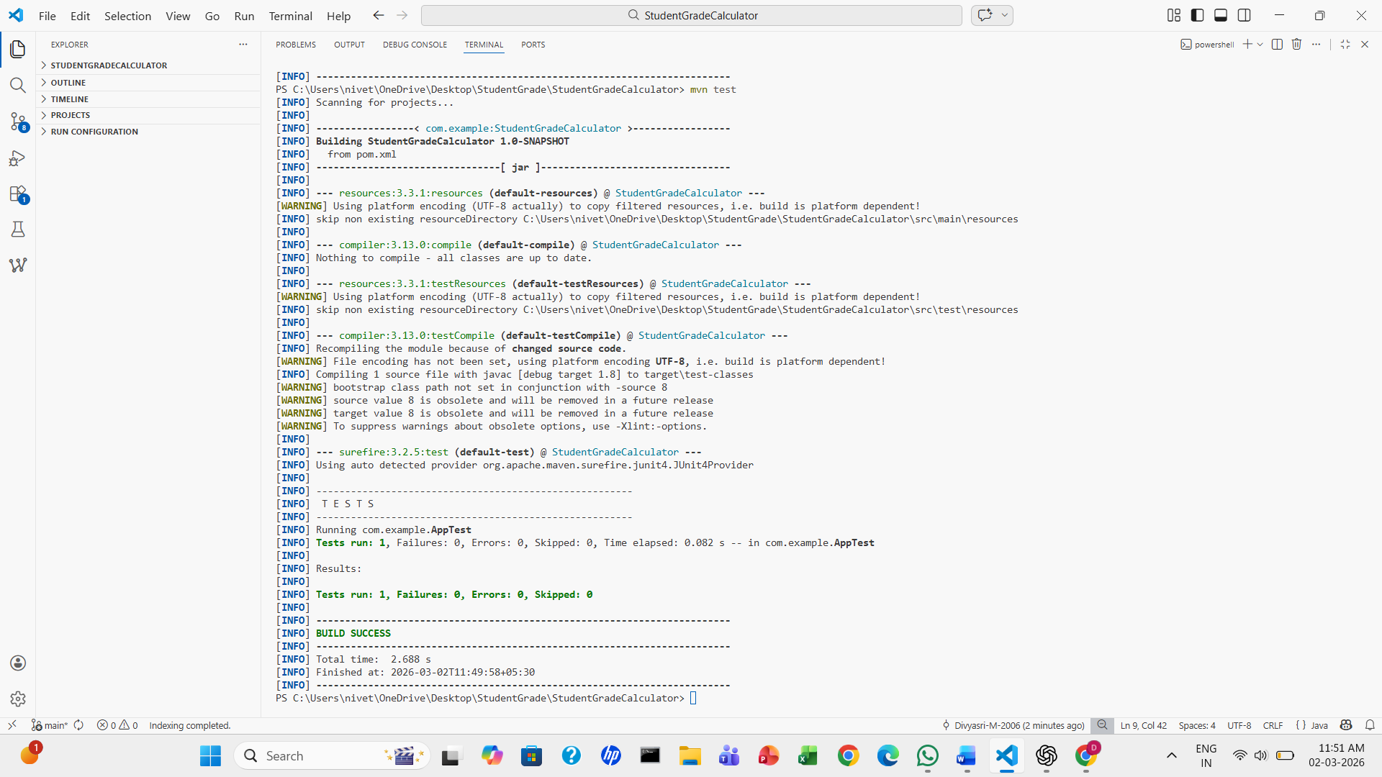

Build the project (mvn clean install)
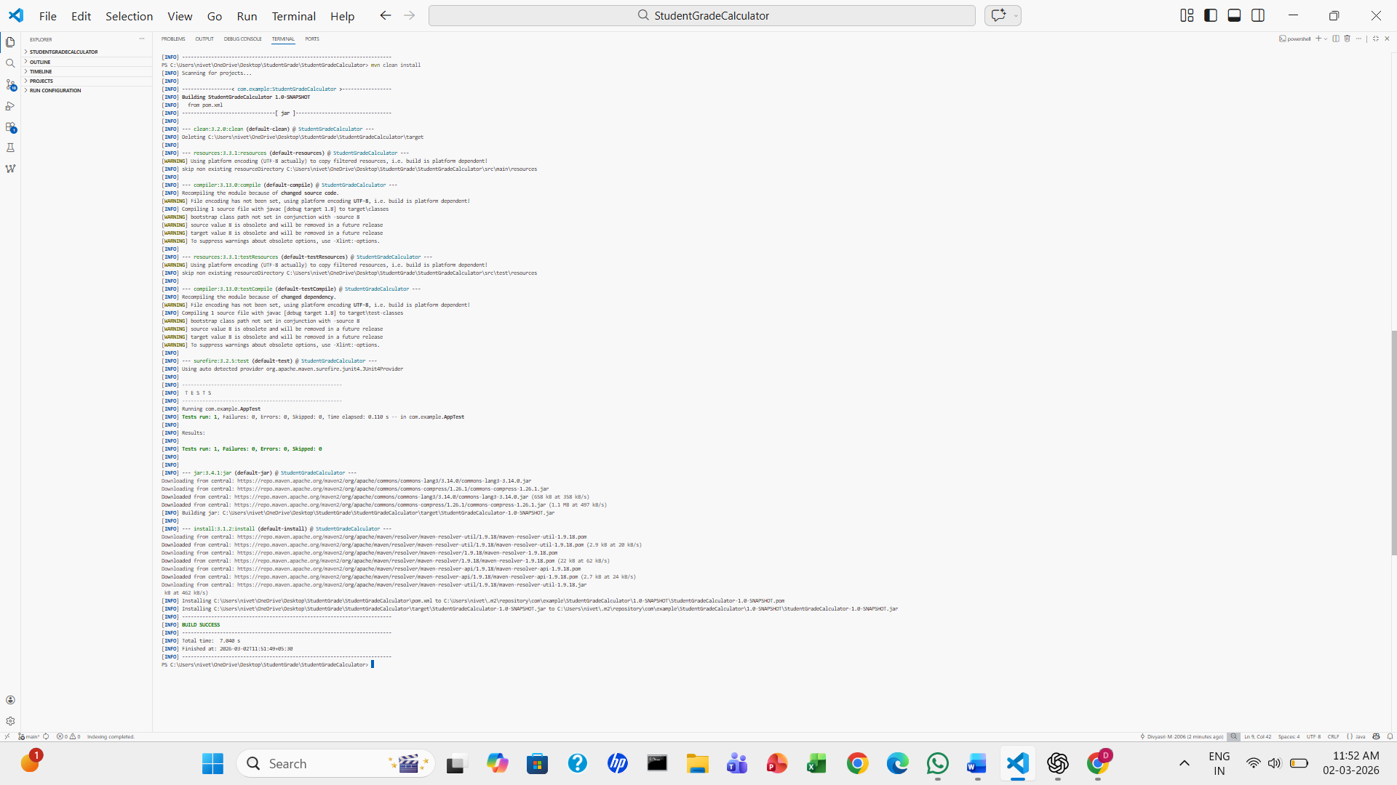
5. Create and Run Jenkins Pipeline
- Create a new Pipeline project in Jenkins.
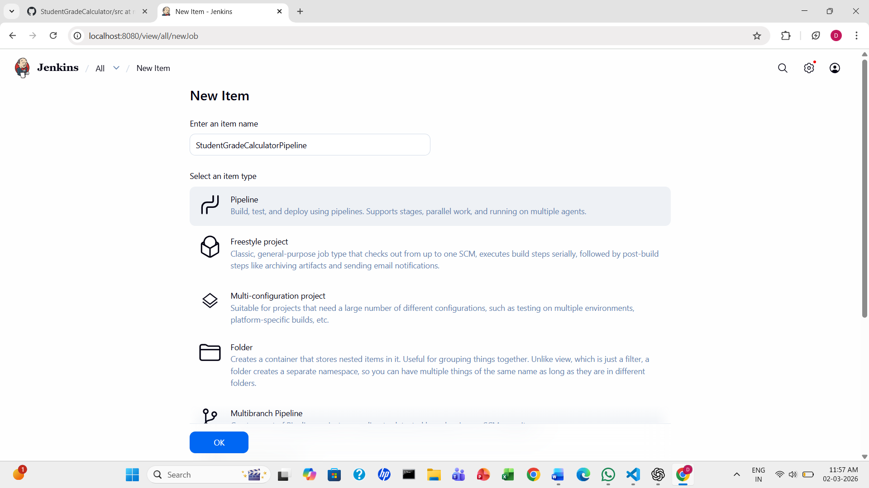

- Create a pipeline script
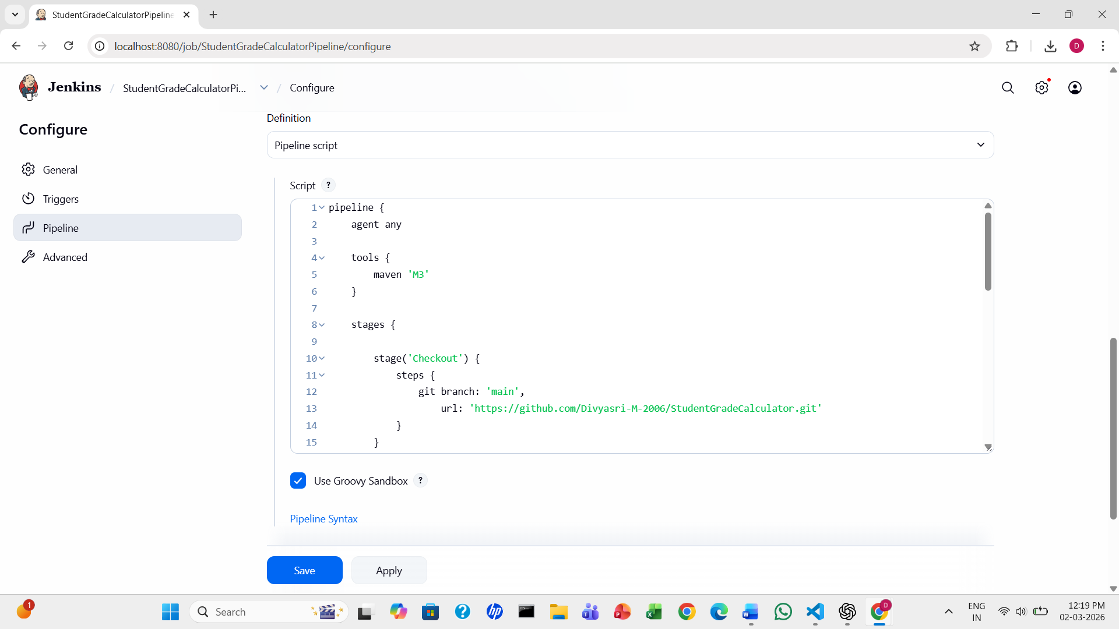
- Execute the pipeline and verify successful build completion.
